Date: MAY 31 2021 File: C:\Karapetyan\18500 Фальц-ножы и лыжи - в расчет\03_program\0.7\18500 Фальц-ножы и лыжи 0.7001.NST

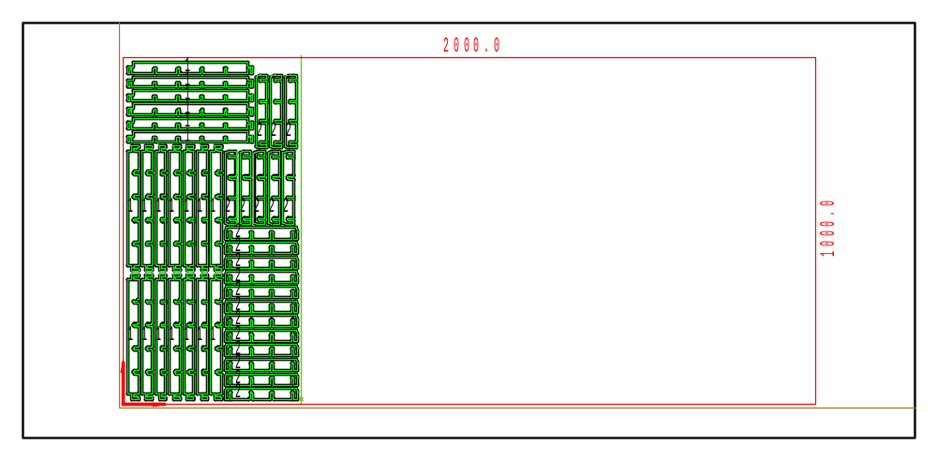

PART INFO
NC File Name: Ê!Å;Ä2RÅ0Ì-ÌÌÌ0.7001%ËÍ
Draft no.: | Version:
Order no.: | Description:
SHEET Number of sheets: 1
Material: Stainless | Sheet size: 2000 X 1000 | T= 1.0
No. of parts: 40 | Part size:
Part weight: | Sheet weight: 15.60 kg
MACHINE:
MODEL: ML3015EX |  | Con. name: SUS304 |  | Table name: ML45CF_R_EX
Gas: N2H | Lens: 7.5 Inches |  | Nozzle diameter: 1.7
Speed: 7000 |  | Used laser power: 4000 |  | Beam diameter (kerf): 0.32
PROGRAM
Number: 4168 | File size: 17375 | Programmer:
Notes:
JOB TIME (min:sec)
Travel: 00:14 | Cut: 04:39 | Pierce: 00:35
Travel way: 5556.3 mm | Cutting way: 0 mm | Pierce Qty.: 40
Total time: 05:27

 | Part name | DX | DY | QTY
2 | Ê#Å;ÌÌÌcurv_10ËÍ | 210 | 32 | 20
1 | Ê#Å;ÌÌÌcurv_10ËÍ | 360 | 30 | 20

